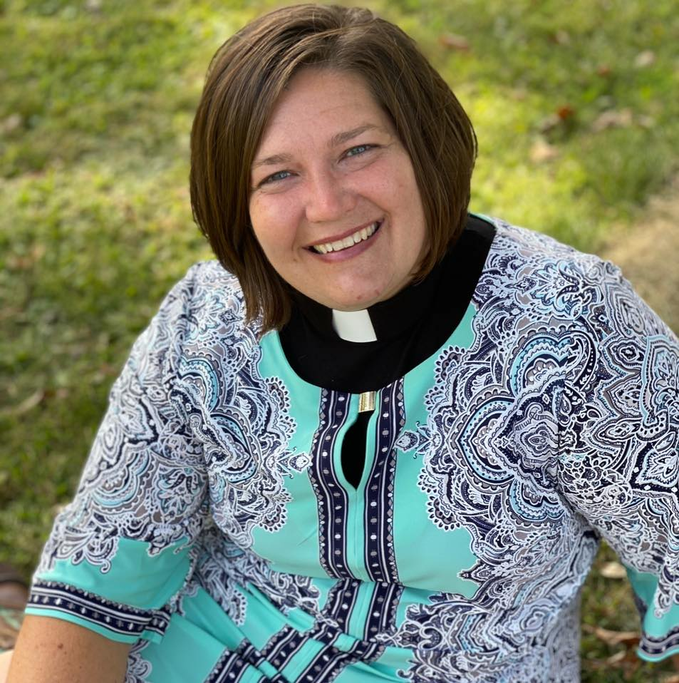
The Lutheran Beacon
Immanuel Evangelical Lutheran Church
304 Spruce St., P.O. Box 466, Tower, MN 55790
December 2022

Advent greetings Immanuel and friends,

Advent
By Meta Herrick Carlson
The sacred call “Prepare!”
Does not ask for lists of logistics.
We do not “Keep awake!” Only to ensure
we are not forgotten at the rapture,
nor is the stillness sedentary.

So do not simply go looking
for a candle scent to capture
what it means to Ponder,
or a gift to prove your Love,
or a tall tree to announce,
“Joy to the World!”

Advent lays bare visions of time bending
into already and not yet,
by the God who tears apart
the hustle, the heavens, the temple curtain!
With no intention of mending
back together our favored boundaries.

This is the thin space where
stillness is powerful and
God is changing our hearts,
so sacred Ponder, Love, and Joy
can birth and shelter.

The miracle grows with slow strength
in the one place we have all called home,
where we do not yet know another way,
while our fullness is being prepared,
carried, and nourished by
the One who says, “Yes.”

In this season of waiting, of preparing our hearts and minds, of pondering the holy…. What kind of lists are you making? To do lists? I want lists? Or lists for the Holy, for God, for our thief in the night to come in and take away all that keeps us captive.

How do you prepare this Advent season? The world around us, our culture and society, have us running from sale to sale, event to event and store to store. When do we slow down to ponder the Holy, to spend time in the presence of the Holy. When do we slow down to ask ourselves what we are waiting for and why. When do we take time to sit in sheer silence to listen, to hear, to embody the Holy?

Friends, I pray this Advent you will find time to be still, to ponder and to know how loved you are by a God who said, “Yes” to you and to the world!

I pray that you can find time to rest in thought, word and deed. A time to reset your heart, mind and soul to prioritize the Holy in your life over the whole busyness this season expects.

And I pray that when we gather on Christmas Eve and Christmas morning your hearts will be ready, open and empty so that you can be filled with the Good news and great joy that to us was born a Savior and then you will be ready to go out and tell it on the mountain or the street or on social media or over the phone that Jesus Christ was born!

Stay awake! Be prepared! Ponder! Wonder!
And remember “God is changing our hearts, so sacred Ponder, Love and Joy can birth and shelter.” May this season of Advent be filled with wonder and joy as you seek the and prepare for the Holy in your lives, in our church, and in the world.

Advent Blessings,
Pastor Liz

December 3 Ruthie Leino
December 5 Roger Rinne
December 5 Tasha Trucano
December 7 Darlene Kittelson
December 9 Alyssa Hujanen
December 9 Diane Meehan
December 10 Rylan Jesme
December 10 John Niemiste
December 11 Jim Carlson
December 12 Angie Gurius
December 12 Elaine Passi
December 14 Nolan Lenci
December 16 Bruce Carlson
December 16 Wayne Dahl
December 19 Mallory Stellmach
December 22 Betty Parker
December 28 Hendrix Wilkinson
December 29 Georgette Larson
December 29 Dennis Passi

December 6 Clint and Jessica Hughes
December 13 Steven & Barbara Burgess

Offering & Attendance

Date Attendance Offering
November 6 48 $ 2,081
November 13 48 $ 1,638
November 20 60 $ 953
November 27 52 $ 2,121
Direct Deposit $ 2,628
Noisy Offerings-November $ 41

Income & Expenses

November 2022
Income: $ 9,529 Expenses: $ 11,830

November 2021
Income: $10,582 Expenses: $ 10,493

December Volunteers

We are in need of volunteers-if you are able to help the church, there is a sign up sheet in the Narthex. Thank you.

USHERS
December 4
December 11
December 18
December 25

COMMUNION PREP
December 4
December 11
December 18
December 25

LECTORS
December 4 Laurie Anderson
December 11 Mary Batinich
December 18 Elaine McGillivray
December 25 Angie Gurius

We sincerely appreciate our Volunteers!
Thank you

"Stewardship Tip: Required Minimum Distributions"
By Pastor Matt McWaters

Stewardship Tip: Required Minimum Distributions
Over the past several years, members of ELCA congregations have wisely used their retirement plan’s “Required Minimum Distribution” to fulfill or exceed their financial pledges to support congregational and synodical mission and ministry. There is a wealth of information about these, so much so that it can get a bit confusing. If you are age 72 or will be soon, learn more about the benefits for you and local non-profits in the clear summary below.

What are Required Minimum Distributions (RMDs)?
To avoid significant IRS tax penalties (50%), retirement account holders aged 72 years old must withdraw a distribution of at least a certain amount determined by the IRS, by December 31 of each year. This distribution is considered Taxable Income, with one exception.

How can I use my RMD to Avoid Paying More Taxes?
To avoid paying Income Tax on your RMD, you may designate your distribution to a non-profit organization of your choice, including your local congregation, parish, or synod.

What Type of Retirement Accounts Apply?
Traditional IRA, SEP IRA, SIMPLE IRA, and ALL Employer Retirement Plans (401k, 403b, etc.) require minimum distributions at age 72.

How is my RMD calculated?
IRS form 590b includes worksheets and information to calculate RMDs. More basically, the full value of qualifying accounts is divided by a life expectancy factor determined by tables included on IRS form 590b. It can be a bit complicated, and I’d encourage those considering directing RMDs to non-profits, to consult with their financial advisor. Use the links provided below to navigate to the IRS
website ¹ and an example of the most commonly used life expectancy factor table. ²

How Do I Designate my RMD?
To use your RMD to fulfill your pledge to your congregation, or to generously bless another non-profit of your choice, funds must be paid directly from your Retirement Account to the non-profit. It cannot be directed to the account holder or beneficiary, first. Contact your retirement account custodian AND consult with your tax advisor to get the process started or to get more information.

¹ Follow this link to the IRS Website’s information page on Required Minimum Distributions.
https://www.irs.gov/forms-pubs/about-publication-590-b

² Table iii, in appendix B is used to determine life expectancy for most RMDs. This can be found on page 63 through this link. https://www.irs.gov/pub/irs-pdf/p590b.pdf
Council Meeting
The council met on Wednesday November 9th 2022 at 9 AM.

Was noted that Sunday School is off to a great start! Confirmation went well. The grief support group has met 2x and has drawn interest from Ely & Cook. A grief support notice will be in the Timberjay.

The social ministry committee will be meeting at the Vermilion Seniors Living on December 14th at 2 o’clock for a Sing-A-Long!!! Everyone is welcome to join!

The next council meeting will be held at 9 AM on Wednesday December 14th.

A full copy of the Council Minutes is on file with the church secretary if interested.

Pastor Liz will be on vacation from December 30th-January 13th. If there are any pastoral emergencies Pastor Erika Foss from Trinity in Cook will be covering for Pastor Liz and can be reached at 218-666-5965. We also have a wonderful Health Ministry committee that is available for any of your needs during this time.

Community Reports Due
Committee chairs please be sure to write your end of the year report and get it to Donna in the office by January 5th. Annual report booklet will be compiled the second week of January so please be prompt in getting your reports in so they can be included in the annual report.

Social Ministry Committee
Will be meeting at the Vermilion Seniors Living on December 14th at 2 o’clock for a Sing-A-Long!!! Everyone is welcome to join!

Also would like to extend our thanks for the bouquet of beautiful fall flowers donated by Doris Mosher for the Vermillion Senior Living birthday celebration that took place in October.

Stewardship Committee
It is time to organize our stewardship committee as we begin a new church year. Stewardship is about managing our faith life, our whole lives as good stewards of all we have, all we are, and all we strive to be. Join Pastor Liz in exploring stewardship as a way of living as this new committee gets to work in helping the congregation experience, exploring and learn that stewardship is not a financial campaign but a whole hearted approach to the way we live, see, do, and act throughout our lives. First meeting will be Tuesday, December 6th at 1:00 p.m. If you would like to be a part of this committee but that day and time does not work for you, please let Pastor Liz know.

Quilting
The quilters will take a break for Christmas. The last quilting session will be December 14th and the quilters will be resuming on January 11th, 2023 at 9 AM.

Join us next Wednesday downstairs in the Fellowship Hall. We start around 9 am and work on quilt projects until coffee break time and wrap up around noon.

If you are interested and would like more information, please contact Penny Jackson at 651-238-3732 (leave a message and I will return your call) or just show up on Wednesday and join the fun!

WELCA
WELCA will not be holding a December meeting. The ladies will be having a Christmas Luncheon on December 10th at noon. They will be having a catered luncheon with door prizes and caroling.

WELCA has new officers; President-Heather Chaulklin, Vice-President-Shelley Padgett, Treasurer-Laurie Anderson, Secretary-Nancy Wagner.

WELCA voted also to send 10% of their monthly offering to the Synod, instead of 50%. This will leave more funds available for local givings.

Thursday Book Study
Thursday book study will take a break for Christmas. The last book study for December will be on December 15th, book study will resume on January 5, 2023 at 10 AM. New members welcome.

Community Meal
December Community Meal
Wednesday, December 28th
4:30-6:30 serving Chili

The following are items that may be donated to help defray the cost of the meal. If you are out and about shopping and want to purchase any of the following items:
Ground Beef
Cans of Kidney Beans
Cans of diced tomatoes
Money

There will be a sign up sheet on the church office door if you would like to sign up to purchase any of the ingredients.

The community meal has been a huge success the last three months, let’s keep this going!

Poinsettia Memorial Garden
If you would like to order a poinsettia for the Poinsettia Garden order forms are available, please fill out form or call the church office at 218-753-2378 and submit with your payment by December 12th. The poinsettias will be ordered from Eveleth Florist and can be purchased for $25. Please note the poinsettias will only be available in red, there seems to be a shortage in the color white.

Blue Christmas Worship
Will take place on Wednesday, December 21st at 7:15 p.m. A time for reflection, candle lighting, singing and prayer as we sit in the presence of God who meets us right where we are at.

Christmas Eve and Christmas Day Worship
Christmas Eve worship will be Saturday, December 24th at 4:00 p.m. with Holy Communion. Worship will include singing our favorite Christmas songs, a special Children’s message, the Good News, scripture and prayer.

Sunday worship on Christmas Day will be at 10:00 a.m. Singing, communion, children’s message, scripture and prayer.

Parish Health Ministry
Our Parish Health Ministry cabinet members are the following and can be contacted with any suggestions for the health ministry. If any of you have family or friends that the ministry may be able to assist in some way, please do not hesitate to contact any of these cabinet members:
* Cathy Carson 753-3885
* Muriel Scott 410-4543
* Barbara Rinne 753-2091
* Kay Hanson 218-248-0198
* Shelly Padgett 218-780-3192
* Ilene Rice 719-331-3447
* Faye Mobilia, Parish Nurse 753-6708
* Marit Kringstad, Council representative 1-612-280-9195

Please note there is a Resource Book/Binder in the church office for your convenience.

Contact Us

Church Office: 753-2378
ielctower@gmail.com
www.towerlutheran.com
www.facebook.com/ImmanuelTower

OFFICE HOURS
Tuesday, Wednesday & Thursday 9:00 – 1:00

STAFF
Pastor: Rev. Liz Cheney
Office Manager: Donna Frank
Minister of Music: MaryBeth Reller
Custodian: James Urick

Members Who Are Homebound

Jim Charles (Birthday May 5)
4559 Shoreline Drive, Apt #406
Spring Park, MN 5584

Carol and Bob Burgess
705 17th St. N. Apt #304
Virginia, MN 55792

Ron Hujanen (Birthday November 25)
Cook Hospital & Nursing Home Room S-204
10 5th St. S.E.
Cook, MN 55723

Eileen Swanson (Birthday July 11)
Vermilion Senior Living
Tower, MN 55790

Scripture readings
for the month of November

December 4 December 11
Isaiah 11:1-10 Isaiah 35:1-10
Psalm 72:1-7,18-19 Psalm 146:5-10
Romans 15:4-13 James 5:7-10
Matthew 3:1-12 Matthew 11:2-11

December 18 December 24
Isaiah 7:10-16 Isaiah 9:2-7
Psalm 80:1-7,17-19 Psalm 96
Romans 1:1-7 Titus 2:11-14
Matthew 1:18-25 Luke 2:1-14{15-20}

December 25
Isaiah 62:6-12
Psalm 97
Titus 3:4-7
Luke 2{1-7}8-20

304 Spruce St.
PO Box 466
Tower, MN 55790

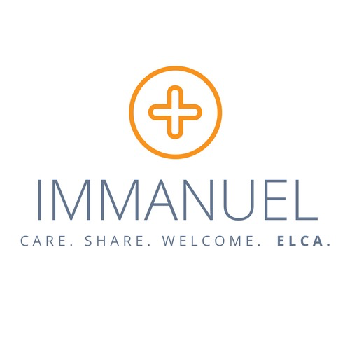

Contact Pastor Liz Cheney at
218-780-8907
lizcheney44@gmail.com (personal & private)
ielctower@gmail.com (public)
In Person Worship 10:00 am Sunday with Holy Communion
Find us online:
Facebook: Immanuel Lutheran Church of Tower
Website: www.towerlutheran.com

